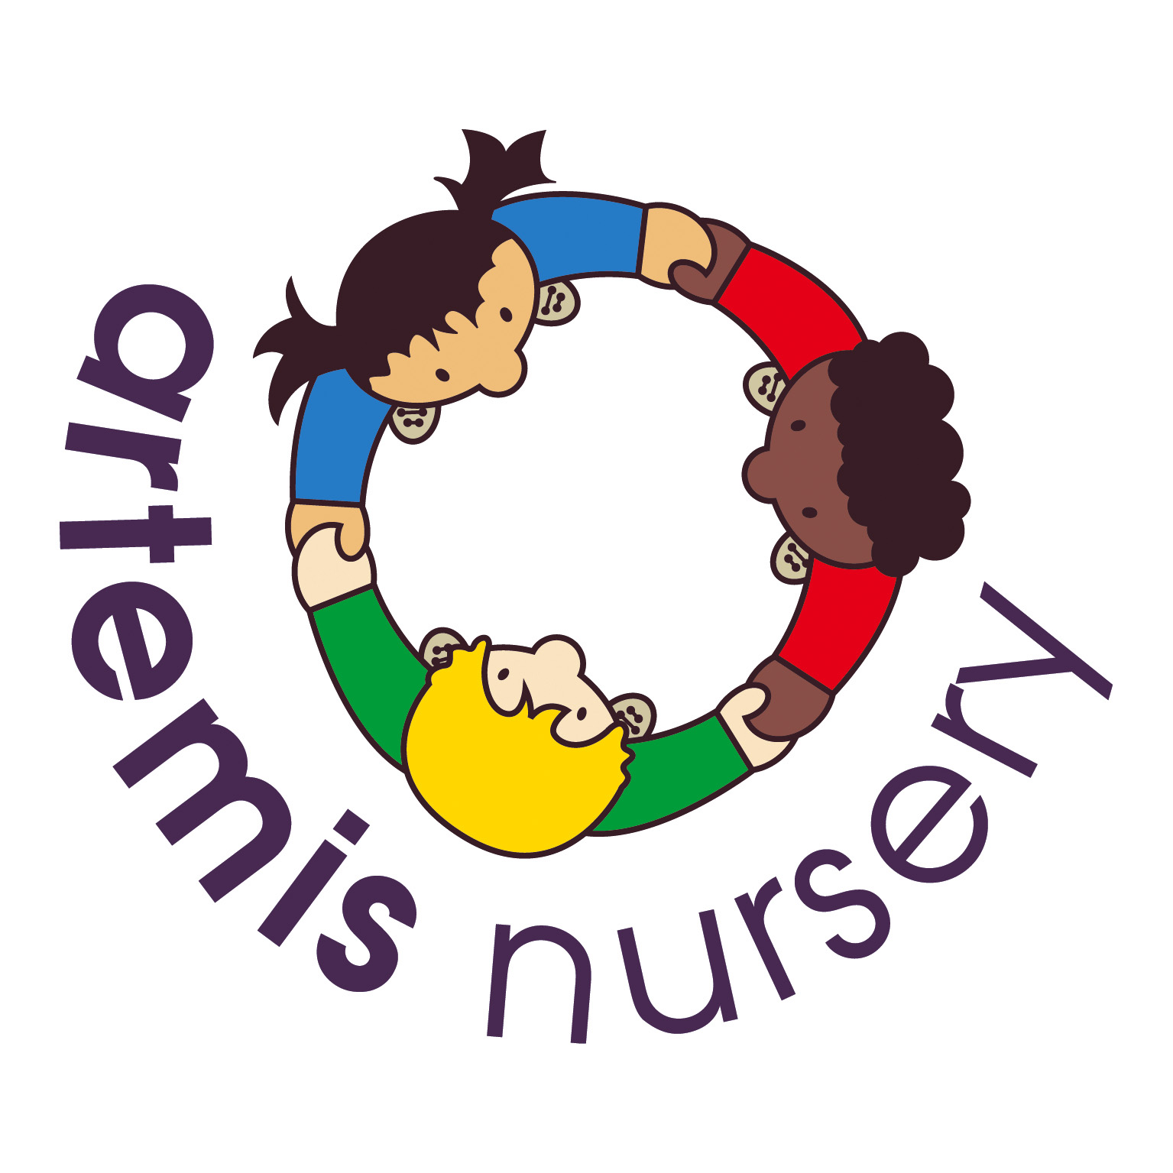
Special Educational Needs Policy

Introduction
At Artemis Nursery we provide an environment in which all children are supported to reach their full potential.

Aims
We have regard for the DfES Special Educational Needs Code of Practice and include all children in our provision. We provide practitioners to help support parents and children with special educational needs [SEN].

At Artemis we identify the specific needs of children with SEN and meet those needs through a range of strategies. We work in partnership with parents and other agencies in meeting individual children's needs and we monitor and review our practice and provision and, if necessary, make adjustments.

- We designate a member of staff to be the Special Educational Needs Co-ordinator (SENCO) and give her name to parents when their child starts at the nursery. Our SENCO is Emma Buggy. She is supported in her role by Kirsty Blanch, Sophie Homewood and Beth Wenden. Emma Buggy has recently completed her Level 3 SENCO award.
- We ensure that the provision for children with special educational needs is the responsibility of all members of the setting.
- We ensure that our inclusive admissions practice ensures equality of access and opportunity.
- We use the graduated response system for identifying, assessing and responding to children's special educational needs.
- We work closely with parents of children with special educational needs to create and maintain a positive partnership.
- We ensure that parents are informed at all stages of the assessment, planning, provision and review of their children's education.
- We provide parents with information on sources of independent advice and support.
- We liaise with other professionals involved with children with special educational needs and their families, including transfer arrangements to other settings and schools.
- We provide a broad, balanced and differentiated curriculum for all children with special educational needs.
- We use a system of planning, implementing, monitoring, evaluating and reviewing Setting Based Support Plans (SBSP) for children with special educational needs.
- We ensure that children with special educational needs are appropriately involved at all stages of the graduated response, taking into account their levels of ability.
- We have systems in place for supporting children during Early Years Action, Early Years Action Plus, Statutory Assessment and the Education Health Care Plan [EHCP] process.
- We use a system for keeping records of the assessment, planning, provision and review for children with special educational needs.
- We provide resources (human and financial) to implement our Special Educational Needs Policy.
- We provide in-service training for parents, practitioners and volunteers.
- We raise awareness of any specialism the setting has to offer, e.g. Makaton trained staff.
- We ensure the effectiveness of our special educational needs provision by collecting information from a range of sources e.g. Individual Education Plan reviews, staff and management meetings, parental and external agency's views, inspections and complaints. This information is collated, evaluated and reviewed annually.

This policy was adopted and agreed at a meeting held at Artemis Nursery on the 1st September 2021.

This policy will be reviewed annually unless a need to review and make changes occurs prior to this.

