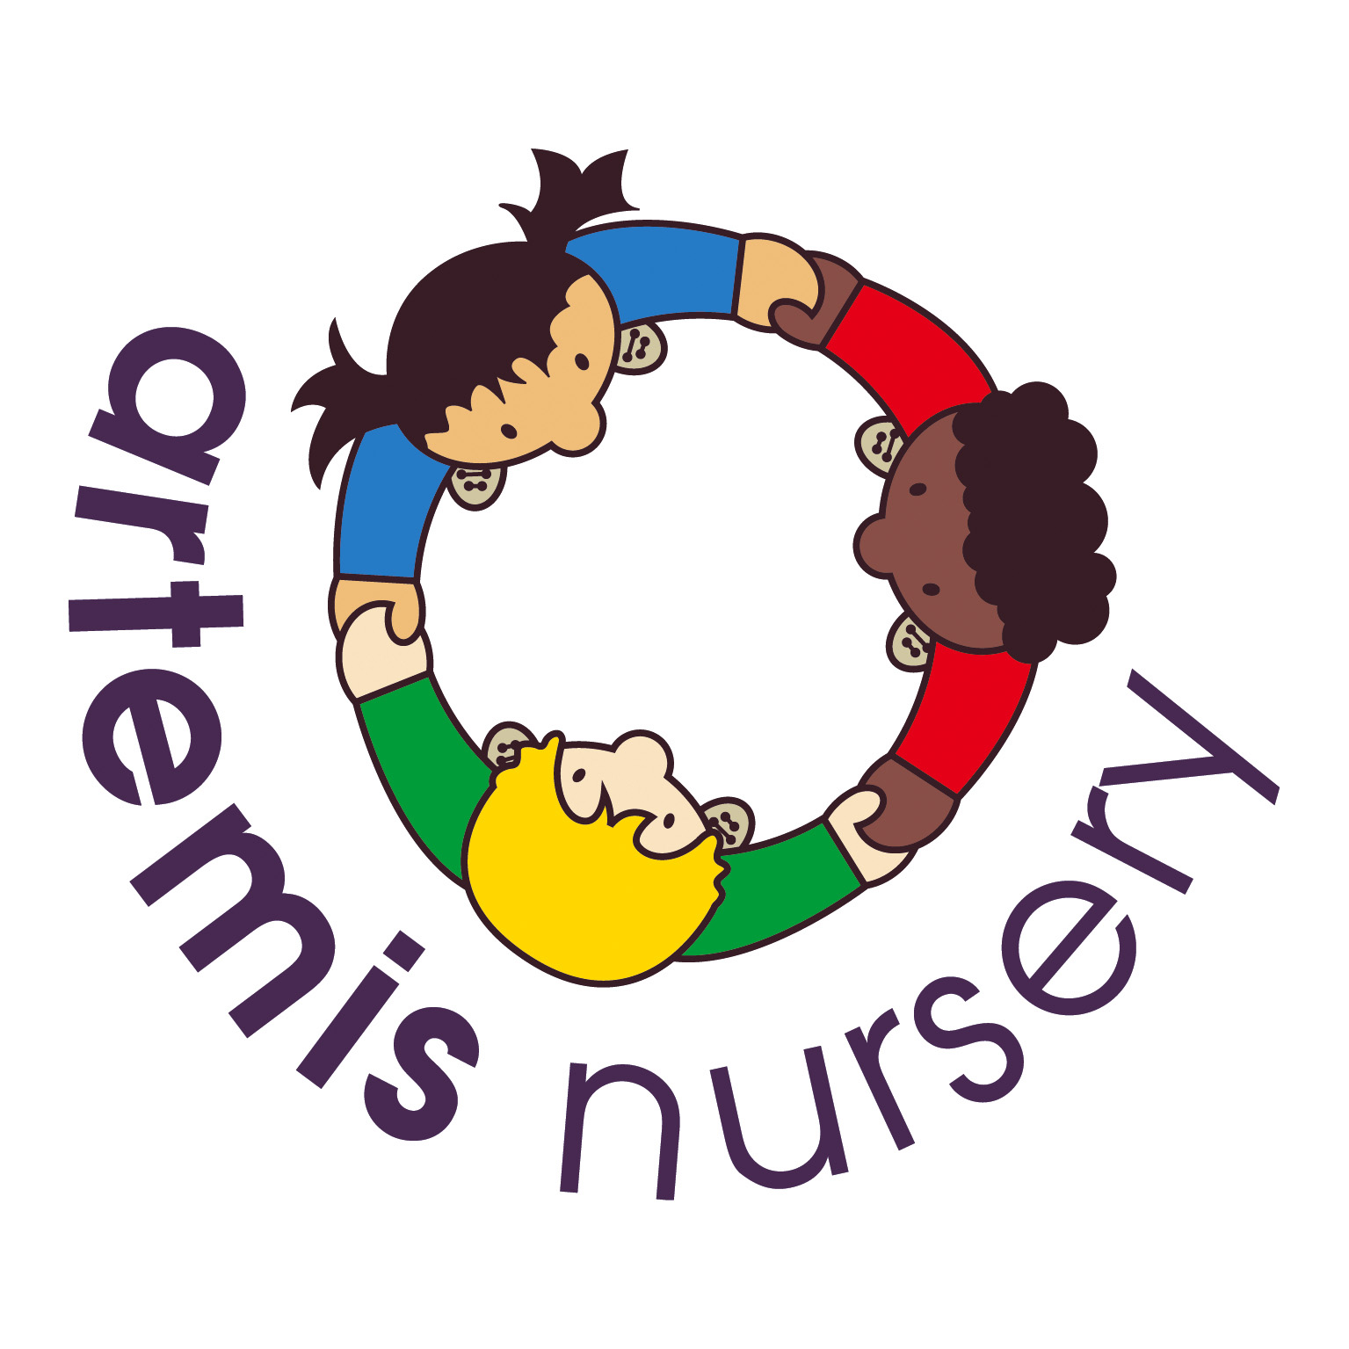
Safeguarding Children and Child Protection
Introduction
We believe that every child has the right to be protected from neglect and abuse. Children cannot learn effectively unless they feel safe and secure. All staff at Artemis nursery are required to contribute to an environment which promotes self-confidence and a feeling of worth. Children must be sure that their concerns will be listened to and acted upon. Everyone has a responsibility to protect children and young people and to report concerns. Children’s needs are paramount and take precedence over the needs of adults in any conflict between the two.

Nurseries play a vital role in the link of recognising and preventing child abuse. Day to day contact with the child puts practitioners in direct contact with the parents and family. General enquiries about the child’s health and welfare form a natural part of the conversation with parents. It is vital that close home/nursery links are developed to the benefit of the child.

Artemis Nursery is committed to promoting awareness of child abuse issues throughout its training and learning programmes for adults. It is also committed to empowering young children, through its early childhood curriculum, promoting their right to be strong, resilient and listened to.

Legal Framework
This policy has regard to the following laws and statutory guidance:

Children Acts 1989 and 2004 define safeguarding and promoting the welfare of children as:
- protecting children from maltreatment
- preventing impairment of children’s health or development
- ensuring that children are growing up in circumstances consistent with the provision
of safe and effective care, and
- undertaking that role so as to enable those children to have optimum life chances and
to enter adulthood successfully.

Working Together to Safeguard Children (2018) sets out how organisations and individuals must work together to safeguard and promote the welfare of children and young people in accordance with Children Acts 1989 and 2004.

Local Safeguarding Children Board (LSCB) Child Protection and Safeguarding Procedures
  - ensures that there are prompt methods for alerting, reporting, investigating and managing a child's protection. The Procedures for Brighton and Hove, East Sussex and West Sussex Local Safeguarding Children Boards are available at http://pansussexscb.proceduresonline.com/chapters/contents.html .

Statutory Framework for the Early Years Foundation Stage 2021
  - the mandatory framework for all early years providers, maintained schools, non-maintained schools, independent schools and all providers on the Early Years Register. The safeguarding and welfare requirements are given legal force by regulations made under Section 39(1)(b) of the Childcare Act 2006.

Children and young people
The definition of a child for safeguarding purposes is anyone under 18 years of age, regardless of circumstances, as defined in the Children Act 1989.
Significant harm
- Harm means ill treatment, or the impairment of health or development, including, for example, impairment suffered from seeing or hearing the ill treatment of another
- Development means physical, intellectual, emotional, social or behavioural development
- Health includes physical and mental health
- Ill treatment includes Sexual Abuse and forms of ill treatment, which are not physical, and
- Where the question of whether harm suffered by the child is significant turns on the child's health and development, his/her health and development must be compared with that which could reasonably be expected of a similar child.
Types of abuse
Abuse and neglect are forms of maltreatment of a child. The following categories overlap and an abused child does frequently suffer more than one type of abuse. For more detailed information, see the Sussex Child Protection and Safeguarding Procedures.

Physical abuse may involve hitting, shaking, throwing, poisoning, burning or scalding, drowning, suffocating or otherwise causing physical harm to a child. Physical harm may also be caused when a parent or carer fabricates the symptoms of, or deliberately induces, illness in a child.

Emotional abuse is the persistent emotional maltreatment of a child so as to cause severe and persistent adverse effects on the child’s emotional development. It may involve:
- making a child feel worthless, unloved or inadequate (high criticism and/or low warmth)
- conveying to the child that they are only there to meet another’s needs
- inappropriate age or developmental expectations
- overprotection and limitation of exploration, learning and social interaction
- seeing or hearing the ill-treatment of another (eg domestic violence)
- serious bullying causing children frequently to feel frightened or in danger, or
- exploitation or corruption

Some level of emotional abuse is involved in all types of maltreatment of a child, though it may occur alone.

Sexual Abuse involves forcing or enticing a child or young person to take part in sexual activities, including prostitution, whether or not the child is aware of what is happening. The activities may involve physical contact, including penetration of any part of the body, or non-penetrative acts. They may include non-contact activities, such as involving children in looking at or in the production of sexual images, including the internet, watching sexual activities, or encouraging children to behave in sexually inappropriate ways.

Neglect is the persistent failure to meet a child’s basic physical and/or psychological needs, likely to result in the serious impairment of the child’s health or development. Neglect may occur during pregnancy as a result of maternal substance abuse. Once a child is born it may involve a parent failing to:
- provide adequate food, clothing and shelter (including exclusion from home or abandonment)
- protect a child from physical and emotional harm or danger
- ensure adequate supervision (including the use of inadequate care-givers), or
- ensure access to appropriate medical care or treatment

It may also include neglect of, or unresponsiveness to, a child’s basic emotional needs.

Female Genital Mutilation
Female genital mutilation (FGM) is a procedure where the female genitals are deliberately cut, injured or changed, but where there's no medical reason for this to be done.
It's also known as "female circumcision" or "cutting", and by other terms such as sunna, gudniin, halalays, tahur, megrez and khitan, among others.

FGM is usually carried out on young girls between infancy and the age of 15, most commonly before puberty starts. It is illegal in the UK and is child abuse.
It's very painful and can seriously harm the health of women and girls. It can also cause long-term problems with sex, childbirth and mental health.
There are four main types of FGM:
- Type 1 (clitoridectomy) – removing part or the entire clitoris.
- Type 2 (excision) – removing part or all of the clitoris and the inner labia (lips that surround the vagina), with or without removal of the labia majora (larger outer lips).
- Type 3 (infibulation) – narrowing of the vaginal opening by creating a seal, formed by cutting and repositioning the labia.
- Other harmful procedures to the female genitals, including pricking, piercing, cutting, scraping or burning the area.

FGM is often performed by traditional circumcisers or cutters who do not have any medical training. However, in some countries it may be done by a medical professional.
Anaesthetics and antiseptics aren't generally used, and FGM is often carried out using knives, scissors, and scalpels, pieces of glass or razor blades.

FGM often happens against a girl's will without her consent and girls may have to be forcibly restrained.

Effects of FGM
There are no health benefits to FGM and it can cause serious harm, including:
• constant pain
• pain and/or difficulty having sex
• repeated infections, which can lead to infertility
• bleeding, cysts and abscesses
• problems passing urine or incontinence
• depression, flashbacks and self-harm
• problems during labour and childbirth, which can be life-threatening for mother and baby
Some girls die from blood loss or infection as a direct result of the procedure.

FGM and Sex
FGM can make it difficult and painful to have sex. It can also result in reduced sexual desire and a lack of pleasurable sensation.

FGM and Pregnancy
Some women with FGM may find it difficult to become pregnant, and those who do conceive can have problems in childbirth.

FGM and Mental Health
FGM can be an extremely traumatic experience that can cause emotional difficulties throughout life, including;
• depression
• anxiety
• flashbacks to the time of the cutting
• nightmares and other sleep problems

In some cases, women may not remember having the FGM at all, especially if it was performed when they were an infant.
Getting help and support
- If someone is in immediate danger, contact the police immediately by dialling 999.
- If you're concerned that someone may be at risk, contact the NSPCC helpline on 0800 028 3550 or fgmhelp@nspcc.org.uk.
Why a FGM is carried out
FGM is carried out for various cultural, religious and social reasons within families and communities in the mistaken belief that it will benefit the girl in some way (for example, as a preparation for marriage or to preserve her virginity).

However, there are no acceptable reasons that justify FGM. It's a harmful practice that isn't required by any religion and there are no religious texts that say it should be done. There are no health benefits of FGM. FGM usually happens to girls whose mothers, grandmothers or extended female family members have had FGM themselves or if their father comes from a community where it's carried out.

Where FGM is carried out
Girls are sometimes taken abroad for FGM, but they may not be aware that this is the reason for their travel. Girls are more at risk of FGM being carried out during the summer holidays, as this allows more time for them to "heal" before they return to school.
Communities that perform FGM are found in many parts of Africa, the Middle East and Asia. Girls who were born in the UK or are resident here but whose families originate from an FGM practicing community are at greater risk of FGM happening to them.
Communities at particular risk of FGM in the UK originate from:
• Egypt
• Eritrea
• Ethiopia
• Gambia
• Guinea
• Indonesia
• Ivory Coast
• Kenya
• Liberia
• Malaysia
• Mali
• Nigeria
• Sierra Leone
• Somalia
• Sudan
• Yemen
The law and FGM
FGM is illegal in the UK.
It is an offence to:
• perform FGM (including taking a child abroad for FGM)
• help a girl perform FGM on herself in or outside the UK
• help anyone perform FGM in the UK
• help anyone perform FGM outside the UK on a UK national or resident
• fail to protect a girl for whom you are responsible from FGM
Anyone who performs FGM can face up to 14 years in prison. Anyone found guilty of failing to protect a girl from FGM can face up to seven years in prison.

Aims of the Policy
We aim to raise awareness of all staff of the importance of safe guarding and child protection and of their responsibilities for identifying and reporting actual or suspected abuse. We want to ensure children and parents are aware that Artemis Nursery takes child protection seriously and will follow the appropriate procedures for identifying and reporting abuse and for dealing with allegations against staff. We aim to support pupil’s development in ways that will foster security, confidence and independence.

Designated Safeguarding Lead (DSL):
Artemis has a designated person to take lead responsibility for safeguarding children. The DSL is responsible for liaison with local statutory children services agencies and with the East Sussex Safeguarding Children Board. They must provide support, advice and guidance to any other staff on an ongoing basis, and on any specific safeguarding issue as required. The DSL has attended all appropriate training that enables them to identify, understand and respond appropriately to signs of possible abuse and neglect. We also have deputy DSL who are also trained to cover in case the lead DSL is called away from the setting or is off sick.

Our Designated Safeguarding Lead [DSL] who co-ordinates child protection issues is: Emma Buggy.
She is supported by Beth Wenden, Kirsty Blanch and Sophie Homewood.
There are several reasons why Artemis Nursery is required to have a Designated Safeguarding Lead:
- So that all child protection concerns and/or knowledge is held by one individual. This means that informed decisions can be taken.
- To offer support to other members of the staff group and ensure that appropriate training has been offered.
- To have a person on the staff who has received more detailed training in child protection issues and has a good understanding of the systems and procedures which exist to protect children.
- For staff to have a point of contact and for other agencies to facilitate liaisons.

Methods
- We ensure all staff and parents are made aware of our safeguarding policies and procedures. Parents receive a copy of the policy when they visit Artemis Nursery and all staff read the policy during their induction and sign to say they have understood and are able to put the policy into practise.
- We provide adequate and appropriate staffing resources to meet the needs of all children.
- Applicants for posts within the setting are clearly informed that the positions are exempt from the Rehabilitation of Offenders Act 1974.
- Candidates are informed of the need to carry out an 'enhanced disclosure' check with the Criminal Records Bureau before posts can be confirmed. Unless they already have one from the Disclosure and Barring Service [DBS] as of September 2013.
- Where applications are rejected because of information that has been disclosed, applicants have the right to know and to challenge incorrect information.
- We abide by Ofsted requirements in respect of references and Criminal Record Bureau checks for staff and volunteers, to ensure that no disqualified person or unsuitable person works at the setting or has access to the children.
- Volunteers do not work unsupervised and we also apply to the DBS for a criminal record check on them.
- We abide by the Protection of Vulnerable Groups Act requirements in respect of any person who is dismissed from our employment, or resigns in circumstances that would otherwise have lead to dismissal for reasons of child protection concern.
- We have procedures for recording the details of visitors to the setting.
- We take security steps to ensure that we have control over who comes into the setting so that no unauthorised person has unsupervised access to the children.
Safer Recruitment and Selection
The selection process will:
- Comply with vetting and barring regulations (www.gov.uk – “Employing People”)
- Always use application forms (CVs should not be accepted)
- Have a minimum of two people checking for any gaps in employment history and explore these gaps during interview
- Ensure at least one reference is from a previous employer and specifically ask if there have been any concerns or allegations about the applicant’s behaviour towards children and/or any disciplinary action and confirm with the referee the applicant’s responsibilities. Compare this information with that provided by the applicant; any inconsistencies or concerns regarding the information provided in a personal reference must be followed up directly with the referee
- Ensure that any concerns arising from the applicant’s medical reference are followed up directly with the applicant and with the employee’s doctor
- Seek to explore at the interview the applicant’s attitudes towards children and young people, their motivation for pursuing the role and managing boundaries
- Always ensure that any other uncertainty or inconsistency about the information provided about the applicant is followed up and resolved
- Check qualifications are valid by requesting certificates are presented
- Check identify by requesting documentation e.g. passport, driving license or similar
- Ensure at least one member on the short listing/interview panel has been suitable trained on safer recruitment
Responding to suspicions of abuse
- We acknowledge that abuse of children can take different forms - physical, emotional, and sexual, as well as neglect. All adults in Artemis Nursery have received training on the signs and symptoms of abuse.
- When children are suffering from physical, sexual or emotional abuse, or may be experiencing neglect, this may be demonstrated through the things they say (direct or indirect disclosure) or through changes in their appearance, their behaviour, or their play.
- Where such evidence is apparent, the child's key person makes a dated record of the details of the concern and discusses what to do with Emma Buggy who is the DSL for Artemis. The information is stored in the child's personal file in a lockable cabinet.
- We refer concerns to the local authority children’s social care department and co-operate fully in any subsequent investigation.
NB In some cases this may mean the police or another agency identified by the Local Safeguarding Children’s Board.
- We take care not to influence the outcome either through the way we speak to children or by asking questions of children.
Recording suspicions of abuse and disclosures
Where a child makes comments to a member of staff that gives cause for concern (disclosure), observes signs or signals that gives cause for concern, such as significant changes in behaviour; deterioration in general well-being; unexplained bruising, marks or signs of possible abuse or neglect that member of staff:
- listens to the child, offers reassurance and gives assurance that she or he will take action;
- does not question the child;
- makes a written record that forms an objective record of the observation or disclosure that includes:
- the date and time of the observation or the disclosure;
- the exact words spoken by the child as far as possible;
- the name of the person to whom the concern was reported, with date and time; and
- the names of any other person present at the time.
These records are signed and dated and kept in the child's personal file which is kept securely and confidentially.
ALL STAFF ARE RESPONSIBLE FOR INFORMATION THEY HAVE RECEIVED OR OBSERVED AND HAVE A DUTY TO ACT APPROPRIATELY. THIS NORMALLY MEANS PASSING THE INFORMATION TO THE DESIGNATED PERSON. FAILURE TO REPORT AND RISK CRIMINAL SANCTIONS.
Making a referral to the local authority social care team
- All members of staff are familiar with the Child Protection recording and referral forms and follow the procedures for recording and reporting.
For any concerns, advice or to report we would phone SPOA [Single Point of Advice] Ground Floor, Ocean House 87-89 London Road St Leonards on Sea East Sussex TN37 6DH on 01323 464222 Email: 0-19.SPOA@eastsussex.gov.uk

Informing parents
- Parents are normally the first point of contact.
- If a suspicion of abuse is recorded, parents are informed at the same time as the report is made, except where the guidance of the Local Safeguarding Children Board does not allow this.
- This will usually be the case where the parent is the likely abuser. In these cases the investigating officers will inform parents.
Liaison with other agencies
- We work within the Local Safeguarding Children Board guidelines.
- We have a copy of 'What to do if you’re worried a child is being abused' for parents and staff and all staff are familiar with what to do if they have concerns.
- We have procedures for contacting the local authority on child protection issues, including maintaining a list of names, addresses and telephone numbers of social workers, to ensure that it is easy, in any emergency, for the setting and social services to work well together.
- We notify the registration authority (Ofsted) of any incident or accident and any changes in our arrangements which may affect the wellbeing of children.
- If a referral is to be made to the local authority social care department, we act within the area’s Safeguarding Children and Child Protection guidance in deciding whether we must inform the child's parents at the same time.
Allegations against staff
- We ensure that all parents know how to complain about the behaviour or actions of staff or volunteers within the setting, or anyone living or working on the premises occupied by the setting, which may include an allegation of abuse.
- We follow the guidance of the Local Safeguarding Children Board when responding to any complaint that a member of staff, or volunteer within the setting, or anyone living or working on the premises occupied by the setting, has abused a child.
- We respond to any disclosure by children or staff that abuse by a member of staff or volunteer within the setting or anyone living or working on the premises occupied by the setting, may have taken, or is taking place, by first recording the details of any such alleged incident.
- We refer any such complaint immediately to the local authority's social care department to inform our Local Advisory Safeguarding Lead to investigate. We also report any such alleged incident to Ofsted and what measures we have taken. We are aware that it is an offence not to do this.
- We co-operate entirely with any investigation carried out by children’s social care in conjunction with the police.
- Where the management and children’s social care agree it is appropriate in the circumstances, the manager will suspend the member of staff on full pay, or the volunteer, for the duration of the investigation. This is not an indication of admission that the alleged incident has taken place but is to protect the staff as well as children and families throughout the process.
Dealing with allegations or concerns against any employee or volunteer
It is essential to act quickly and effectively if an allegation is made, or if there is suspicion or concern about a professional or volunteer’s relationship with a child, young person or group of children/young people, particularly if they have:
- Behaved in a way that has harmed, or may have harmed, a child
- Possibly committed a criminal offence against or related to, a child
- Behaved towards a child or children in a way that indicates she/he is unsuitable to work with children
If an allegation is made, or a concern arises, about a member of staff or volunteer, ensure that the Settings Named Person is informed immediately; the Named Person must immediately contact the Local Authority Designated Officer (LADO) Samantha Efde on 01323 466606.
The LADO is available to provide advice or support in any allegations process, including advising whether or not immediate suspension of the person concerned should be initiated.
If the LADO is unavailable, the Head of Children’s Safeguarding must be contacted on 01273 481289; if the concern is raised out of hours then the out of hours service or, in an emergency, the police must be contacted.
Records should be secured and will be strictly limited to relevant staff and external professionals on a need to know basis only.
The member of staff or volunteer should be treated fairly and honestly, helped to understand the concerns expressed, the process being followed and any outcomes of the process. The member of staff will be suspended on full-pay whilst the investigation is on-going. This is necessary in order to protect both parties.
Senior managers should seek advice from the LADO and Children’s Social Care or Police before informing the person who is subject to an allegation.
ALLEGATIONS OF ABUSE MADE AGAINST OTHER CHILDREN
At Artemis we believe that all children have a right to attend Nursery and learn in a safe environment. Children should be free from harm by adults in the school and other children. We recognise that some children will sometimes negatively affect the learning and wellbeing of others and their behaviour will be dealt with under the school’s Behaviour Policy.
Safeguarding allegations
Occasionally, allegations may be made against children by others in the Nursery, which are of a safeguarding nature. Safeguarding issues raised in this way may include physical abuse, emotional abuse, sexual abuse and sexual exploitation. It is likely that to be considered a safeguarding allegation against a child, some of the following features will be found.
The allegation:
•is made against an older child and refers to their behaviour towards a younger child or a more vulnerable child
•is of a serious nature, possibly including a criminal offence
•raises risk factors for other children in the Nursery
•indicates that other children may have been affected by this child
•indicates that young people outside the school may be affected by this child
Safeguarding issues against a pupil could include:
Physical Abuse
•violence, particularly pre-planned
Emotional Abuse
•threats and intimidation
Sexual Abuse
•indecent exposure, indecent touching or serious sexual assaults

Minimising the risk of safeguarding concerns towards pupils from other pupils

On occasion, some pupils will present a safeguarding risk to other pupils. The Nursery should be informed of any safeguarding concerns, for example, they are coming back into Nursery having experienced serious abuse themselves.

These children will need an individual risk management plan to ensure that other children are kept safe and they themselves are not laid open to malicious allegations. There is a need to balance the tension between privacy and safeguarding.

What to do
When an allegation is made by a child/parent against another child, members of staff should consider whether the complaint raises a safeguarding concern. If there is a safeguarding concern the DSL should be informed. A factual record should be made of the allegation, but no attempt at this stage should be made to investigate the circumstances.
The DSL should contact SPOA to discuss the case. It is possible that Children’s Social Care are already aware of safeguarding concerns around this young person. The DSL will follow through the outcomes of the discussion and make a statement of referral where appropriate.
The DSL will make a record of the concern, the discussion and any outcome and keep a copy in the files of both children.
If the allegation indicates a potential criminal offence has taken place, the police should be contacted at the earliest opportunity and parents informed (of both the children being complained about and the alleged victim).
Where neither Children’s Social Care nor the police accept the complaint, a thorough Nursery investigation should take place into the matter using the Nurseries usual procedures.
In situations where the Nursery considers a safeguarding risk is present, a risk assessment should be prepared along with a preventative, supervision plan.
The plan should be monitored and a date set for a follow-up evaluation with everyone concerned.
Disciplinary action
- Where a member of staff or a volunteer is dismissed from the setting because of misconduct relating to a child, we notify the Independent Barring Board administrators so that the name may be included on the Protection of Children and Vulnerable Adults Barred List.
Training
- We seek out training opportunities for all adults involved in the setting to ensure that they are able to recognise the signs and signals of possible physical abuse, emotional abuse, sexual abuse and neglect and that they are aware of the local authority guidelines for making referrals.
- We ensure that all staff knows the procedures for reporting and recording their concerns in the setting.
Planning
- The layout of the rooms allows for constant supervision. No child is left alone with staff or volunteers in a one-to-one situation without being visible to others.
Curriculum
- We introduce key elements of keeping children safe into our programme to promote the personal, social and emotional development of all children, so that they may grow to be strong, resilient and listened to and that they develop an understanding of why and how to keep safe.
- We create within the setting a culture of value and respect for the individual, having positive regard for children's heritage arising from their colour, ethnicity, languages spoken at home, cultural and social background.
- We ensure that this is carried out in a way that is developmentally appropriate for the children.
Confidentiality
- All suspicions and investigations are kept confidential and shared only with those who need to know. Any information is shared under the guidance of the Local Safeguarding Children Board.
Commissioning and Procurement
Any external agencies visiting the premises must respect Artemis’ policies and procedures at all times and not discuss overheard conversations or information regarding children and families outside the setting. Any concerns regarding safeguarding must immediately be advised to the Lead Safeguarding Practitioner or if concerns relate to that member of staff the complainant must contact the Local Authority Designated officer.
Breaches of this Safeguarding Policy by external contractors or visitors will be taken very seriously and appropriate action will be taken.
Support to families
- We believe in building trusting and supportive relationships with families, staff and volunteers in the group.
- We make clear to parents our role and responsibilities in relation to child protection, such as for the reporting of concerns, providing information, monitoring of the child, and liaising at all times with the local children’s social care team.
- We will continue to welcome the child and the family whilst investigations are being made in relation to any alleged abuse.
- We follow the Child Protection Plan as set by the child’s social care worker in relation to the setting's designated role and tasks in supporting that child and their family, subsequent to any investigation.
- Confidential records kept on a child are shared with the child's parents or those who have parental responsibility for the child in accordance with the Confidentiality and Client Access to Records procedure and only if appropriate under the guidance of the Local Safeguarding Children Board.
This policy was adopted and agreed at a meeting held at Artemis Nursery on the 1st September 2021.

This policy will be reviewed annually unless a need to review and make changes occurs prior to this.

