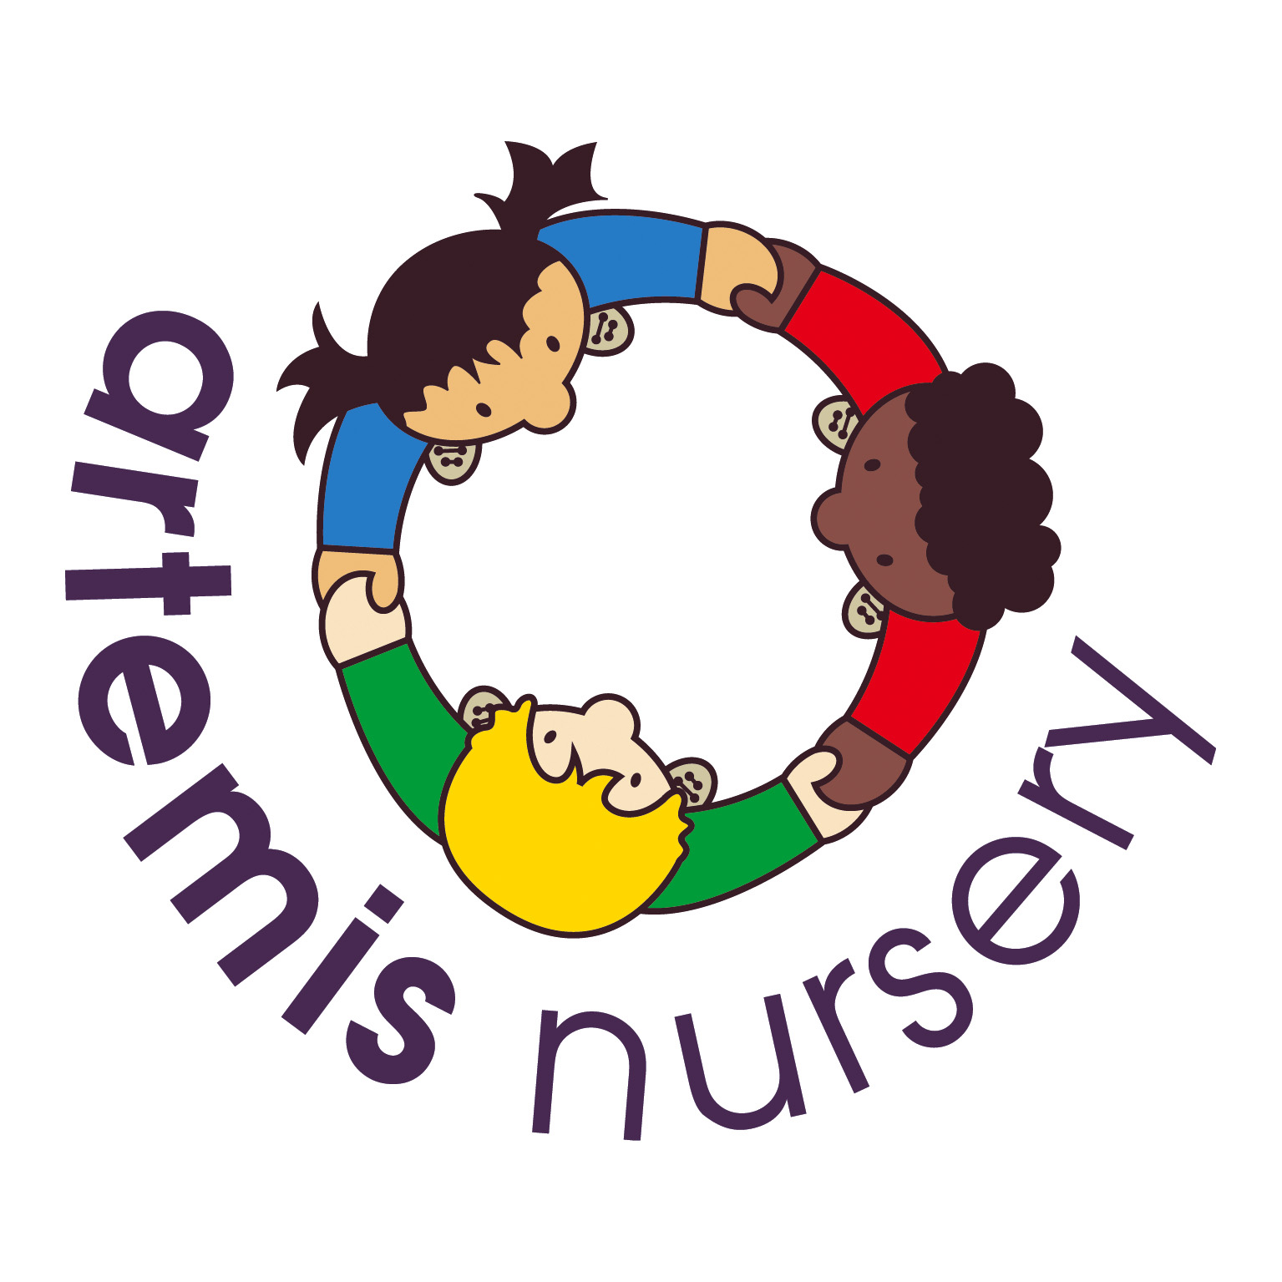
Prevent Duty Policy

Prevent is about safeguarding people and communities from the threat of terrorism. Prevent is part of CONTEST, the Government’s counter-terrorism strategy. It aims to stop people becoming terrorists or supporting terrorism.
In order for Artemis Nurseries to fulfil the Prevent Duty it is essential that staff are able to identify children who may be vulnerable to radicalisation, and know what to do when they are identified. Protecting children from radicalisation is seen as Artemis Nurseries wider safeguarding duty.
Artemis Nursery builds children’s resilience to radicalisation by promoting fundamental British values (see British values policy).
Artemis understand that there is no single way of identifying an individual who is likely to be susceptible to a terrorist ideology. As with managing other safeguarding risks, staff are alert to changes in children’s behaviour which could indicate that they may be in need of help or protection.
Attentional training – Management and all staff have all completed an E – learning course which is a programme provided by Channel. It focuses on providing support at an early stage to people who are identified as being vulnerable to being drawn into terrorism. This e-learning course includes information on how Channel links to the government's counter-terrorism strategy (CONTEST) through the Prevent strategy. It also provides guidelines on how to identify people who may be vulnerable to radicalisation and how to refer them to the Channel programme
Artemis understand that further advice can be found:
- DfE – The Prevent Duty
- HM Government – Revised Prevent Duty Guidance for England and Wales

British Values Policy
Aim
The welfare of your child is paramount to us. It is our duty to protect all children within our care, complying with all relevant legislation. This policy is the implementation of our Safeguarding policy in relation to British Values and Prevent Duty.

Method

Democracy:
making decisions together. As part of the focus on self-confidence and self-awareness as cited in Personal, Social and Emotional Development:

The staff will encourage children to see their role in the bigger picture, encouraging children to know their views count, value each other’s views and values and talk about their feelings, for example when they do or do not need help. When appropriate demonstrate democracy in action, for example, children sharing views on what the theme of their role play area could be with a show of hands.

Staff will support the decisions that children make and provide activities that involve turn-taking, sharing and collaboration. Children should be given opportunities to develop enquiring minds in an atmosphere where questions are valued.

Rule of law:
understanding rules matter as cited in Personal Social and Emotional development as part of the focus on managing feelings and behaviour:

Staff will ensure that children understand their own and others’ behaviour and its consequences, and learn to distinguish right from wrong. Staff will collaborate with children to create the rules and the codes of behaviour, for example, to agree the rules about tidying up and ensure that all children understand rules apply to everyone.

Individual liberty:
freedom for all as part of the focus on self-confidence & self-awareness and people & communities as cited in Personal Social and Emotional development and Understanding the World:

Children should develop a positive sense of themselves. Staff provide opportunities for children to develop their self-knowledge, self-esteem and increase their confidence in their own abilities, for example through allowing children to take risks on an obstacle course, mixing colours, talking about their experiences and learning.

Staff will encourage a range of experiences that allow children to explore the language of feelings and responsibility, reflect on their differences and understand we are free to have different opinions, for example in a small group discuss what they feel about transferring into Reception Class.

Mutual respect and tolerance:
treat others as you want to be treated. As part of the focus on people & communities, managing feelings & behaviour and making relationships as cited in Personal Social and Emotional development and Understanding the World:

Staff should create an ethos of inclusivity and tolerance where views, faiths, cultures and races are valued and children are engaged with the wider community.

Children should acquire a tolerance and appreciation of and respect for their own and other cultures; know about similarities and differences between themselves and others and among families, faiths, communities, cultures and traditions and share and discuss practices, celebrations and experiences.

Staff encourage and explain the importance of tolerant behaviours such as sharing and respecting other’s opinions.

Staff promote diverse attitudes and challenge stereotypes, for example, sharing stories that reflect and value the diversity of children’s experiences and providing resources and activities that challenge gender, cultural and racial stereotyping.

This policy was adopted and agreed at a meeting held at Artemis Nursery on the 1st September 2021.

This policy will be reviewed annually unless a need to review and make changes occurs prior to this.

