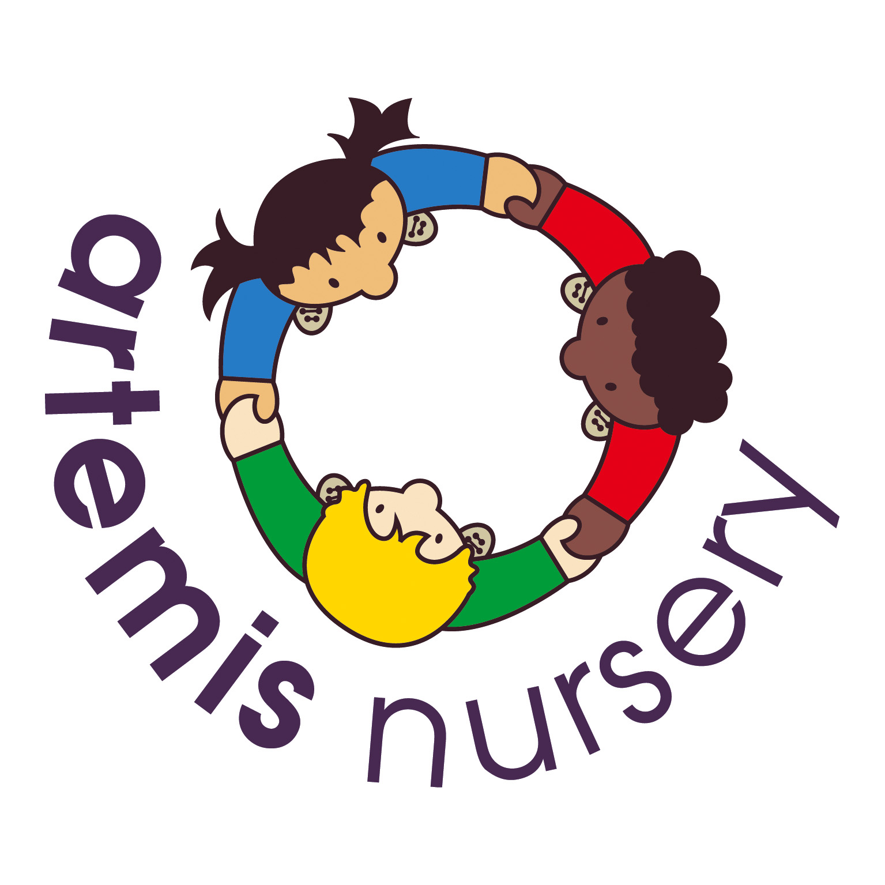
Covid 19 Policy

Introduction
The purpose of this policy is to share procedures in detail to enable us to protect all employees of Artemis Nurseries, and parents and children, from encountering Coronavirus (COVID-19). We aim to maintain the minimum level of staff needed to continue to provide early years education and to meet the welfare and care needs of the children who attend the setting. This is will help us to ensure that the prevention of the spread of Coronavirus (COVID-19) remains at a minimum risk.
Nursery Closure
We will continue to monitor the risk posed by the pandemic, and will follow all guidance from the government and our local authority. At any time that it is felt necessary to prevent the spread of Coronavirus (COVID-19) and to ensure the health and safety of all our employee’s, children and parents, we may, at any time, revert to a closed status, with no children permitted on site, or to a partially closed status, where places may be limited to, but not excluding, children of critical key worker, special educational needs (SEND), children whom have an EHCP plan in place, children in care and children who have a social worker allocated to them already.
Monitoring
Artemis is closely monitoring and gathering information from the Department of Health England, The Department of Education, our Local Authority ( East Sussex) and any and all guidelines delivered and updated through official government sources constantly to ensure that we have the most up to date information to ensure the containment of the Coronavirus (COVID-19).
General
- Employees are always advised to practise strict hygiene and cleanliness procedures.
- Employees must wash their hands at regular intervals for a minimum of 20 seconds using soap and warm water.
- Employees are advised to cough or sneeze into their elbow when a tissue or other vessel cannot be reached in time and are then to always wash their hands afterwards.
- Employees are advised to avoid contact with others, such as handshakes or hugs and are to maintain a social distance of 2 meters (6ft). Even though guidance has said that from the 4th July 2020, this can be reduced to 1 meter if you cannot do the 2 meters, we at Artemis will be continuing with the 2 meters for social distancing and ask parents to do the same during the dropping off and collecting of their children.
- Employees are to avoid touching their eyes, nose, and face whilst at Nursery and whilst children are in their care.
- Employee’s must wash all their uniform before entering the premises for their next shift. This must include the cleaning of all appropriate footwear.
- Throughout the day, practitioners must clean and sanitise all surfaces, toys, toileting areas, outdoor areas and equipment, ready for the next ‘bubble’ of children to use, this includes all outside toys. All outside toys are to be brought in from the garden, at the end of every working day and before weekend/holiday period closures or closures for health and safety measures.
- Only disposable paper towels, provided by Artemis, will be permitted for use whilst cleaning during this time.
- No prams, scooters, bikes, or any other items are to be left inside the setting at any time.
- Please be aware that your children will meet both staff members and other children attending the setting during the session times. Although every measure will be taken to ensure that your child has minimal contact with others, children of the early years age group will inevitably want to hug and touch others through play or when needing comfort. Therefore it is vital that not only we will adhere to best practise hygiene policies throughout the day, but that parents can also support this by changing their children into different clothing when they return home and placing that days clothing in the wash and by following the government’s guidelines at all times. If your child needs comfort, our staff will comfort them and will do their absolute best to make sure that all their social, emotional and wellbeing is met whilst in attendance at Artemis.
Hygiene on Arrival
- All parents and children must adhere to the social distancing floor markings when waiting at our sites and must not cross over these markings until the parent in front of them has left.
- Only the parent(s) of the child may collect the child and from the 6th July, one other at a time, from one other household, in case of work commitments/emergencies, may collect. For example a Grandmother and Grandfather from the same household may collect individually. This will reduce the social contact to help keep the welfare and safety of our staff a top priority.
- Staff will greet parent’s wearing the appropriate PPE equipment, as supplied by Artemis, when accepting your child onto the premises. This will include disposable gloves and aprons. As well as face masks, if the need requires or the staff member wishes to. These will be disposed of after every use.
- All parents and children must use our one-way system when entering the grounds near our building which will be clearly marked, when dropping off and collecting children.
- Parents are asked not to bring in any items from home, this also includes toys. If there is a need for a specific item which is conducive to your child attending the setting, then please discuss this with the practitioners and agree before an item comes onto the premises. All clothing that the children attend in must have been washed prior to the day of your arrival. If you are to re-use the same clothing, for example your child’s uniform, then this must be washed daily before the arrival of your child on their next session.
- Spare clothes will remain at nursery, until they are needed and then we ask that they are replaced when your child is next in with clean clothes.
- No bags are to be brought from home into the setting. Your child must attend every day with the minimum requirement for the weather forecast for that day only. This could be, but not an exhaustive list of, weather sensible footwear, a coat, jumper/cardigan/t-shirt, pants, skirt, or shorts. Please assess the weather conditions before your child attends the setting each day.
- We will be continuing to provide all meals [rather than ask you to bring in a packed lunch for your child] as we believe that we can ensure all items of cutlery, plates etc can be hygienically washed after each use. Children will be given drinks and healthy snacks as normal during the day using our items which are sterilised daily.

Hygiene during the day
- Children will be actively encouraged to wash their hands after every activity or after playing in a specific area. We will use water and hand soap for this with a minimum wash time of 20 seconds per child, demonstrating good modelling behaviours for the children to see best practise when doing this. After an activity/toy playing session has ended, all equipment/toys shall be cleaned after every use.
- Children’s temperatures will be taken upon arrival to the setting and throughout the day, if the need arises. If upon arrival, your child is displaying a temperature of 37.8 degrees, has a new cough, looks generally unwell or is displaying any other signs associated with coronavirus (CORVID-19) then your child will be have to be taken home and you will need to follow the Department of Health’s guidelines at present. You will be given a date of when your child can attend again. Your child must not attend the setting before this date has expired. This will then help to control the spread of the virus within our setting. Should your child get tested during this time period, and a negative test comes back before the expiration of the allotted time, then providing you consent to give a copy of this for insurance purposes, your child may then attend sooner.
- Should you or an adult present with symptoms within your household, then you have a duty of care to inform the setting at your first available opportunity and without unreasonable delay.
- Children will still be allowed to collect their own snack on their plates using the tongs and utensils provided which will then be cleaned before each new child uses the equipment. The same process will be followed when the children access milk and water during meal time. This will help to promote confidence and motor skills whilst maintaining best practice with hygiene procedures.
- Not more than two employees at any one time, will be permitted into the staff office. The office will be cleaned during and at the end of every day.
- During snack, nappy changes/toileting help and any other close contact with the children, staff will be required to wear the appropriate PPE equipment as supplied by Artemis.
- Staff are only permitted to bring one small bag, if necessary and a coat. No other items from home shall be permitted in the setting during this time.
- Both the kitchen and toileting/nappy changing areas will be regularly cleaned and sanitised during the day by all employees.
Hygiene upon leaving
- All parents must remain on the social distancing stickers until called forward by a member of staff to collect their child.
- All staff members will be wearing PPE protective equipment when handing over your child at the end of the day.
- If your child comes home in spare clothing from the setting. Please can you ensure that this is washed and returned to the setting upon your child’s next attend session.
- Once your child has been collected, please leave the premises by following the route laid out in our arrivals and departures procedures. Please do not remain outside of the building for any other reason.
- If you require to talk to the staff regarding your child, a telephone consultation will be arranged for you.
- If you are required to sign an accident/incident form from an occurrence that may have happened that day, then these will now be found on the portal.
- Please bear in mind the social distancing rule of two meters in-between groups of people from outside of your household and to exit swiftly from the setting to allow other parent’s to collect their child. This will also help to minimise contact for all visitors of the setting.

This policy was adopted and agreed at a meeting held at Artemis Nursery on the 1st September 2021.

This policy will be reviewed annually unless a need to review and make changes occurs prior to this.

